Repeater –
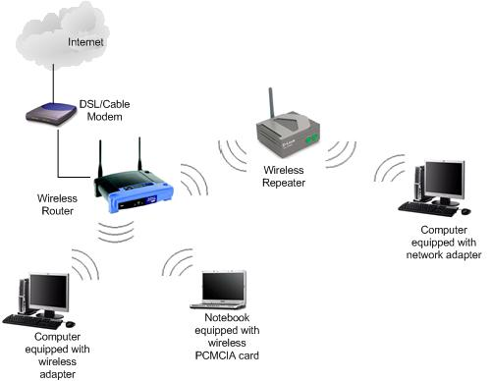
When a signal is transmitted in a channel with some energy, then the signal after travelling some distance in the channel, the energy of the signal would be getting down and this property is termed as Attenuation and we need a Repeater at that point.
Repeater would amplify the signal and transmit / repeat the signal from that point where it got down .
At the bottom, in the physical layer, we find the “repeaters”. These are analog devices that are connected to two table segments. A signal appearing on one of them is amplified and put out on the other. Repeaters do not understand frames, packets, or headers. They understand volts.
Hub –
Hub is a device which joins n systems wherein every system is connected to every other system.
A HUB has number of input lines that it joins electrically. HUBs differ from repeaters in that they do not usually amplify the incoming signals and are designed to hold multiple line cards each with multiple inputs ,but the differences are slight.
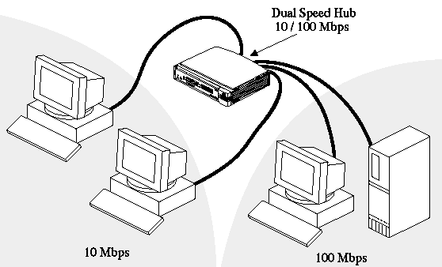

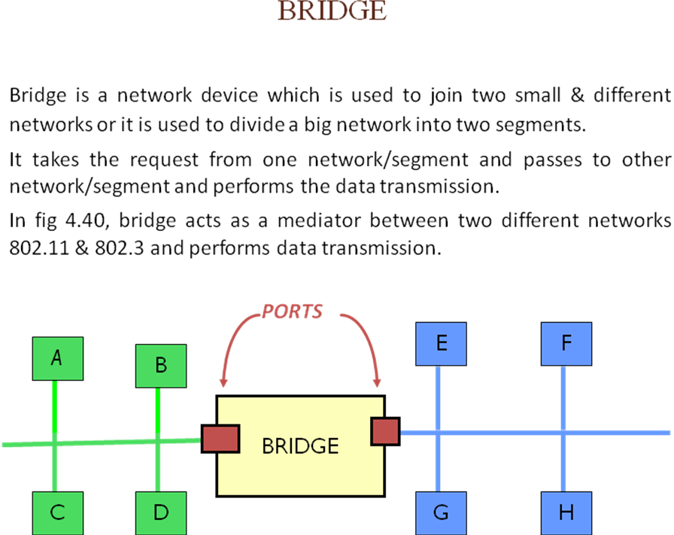
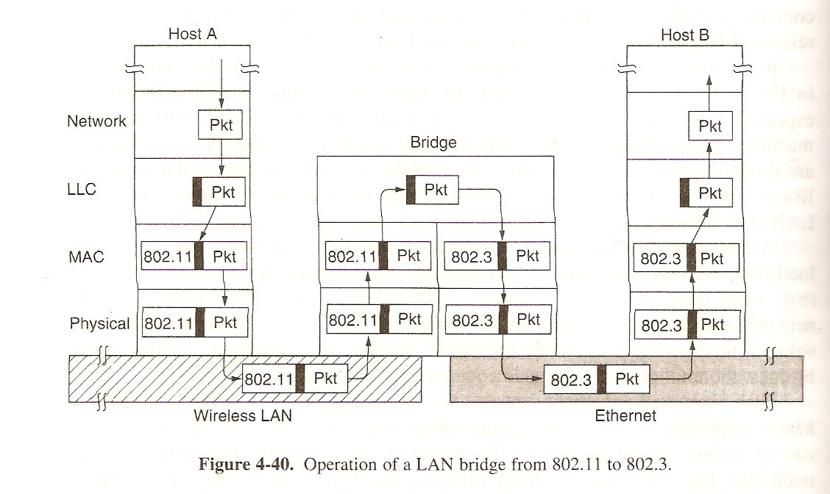
Here in fig-4.40., bridge at the center takes a request from host A of 802.11 network and passes to host B of 802.3 network and vice versa.
Working of a Bridge -
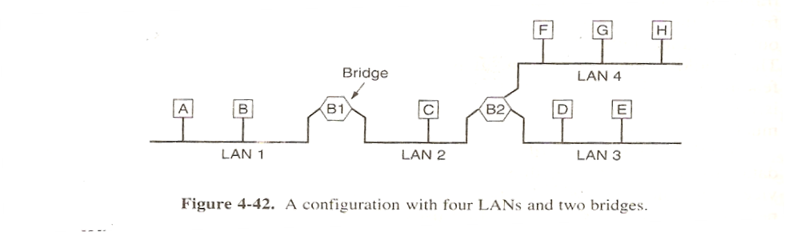
In fig 4.42, Initially FLOODING process takes place. i.e. every system will transmit a hello packet across all the available channels / ports and tell their existence. i.e. A will send a Hello packet across all ports and tell its MAC address, LAN1 and transmitted through a particular port and this data will be LEARNED by the bridge B1. The same B1 learns that C from LAN2 from some other port.
- Then If A sends a frame to E - the frame must be forwarded by the bridge.
- If A sends a frame to B - there is no reason to forward the frame.
Spanning Tree Bridge -
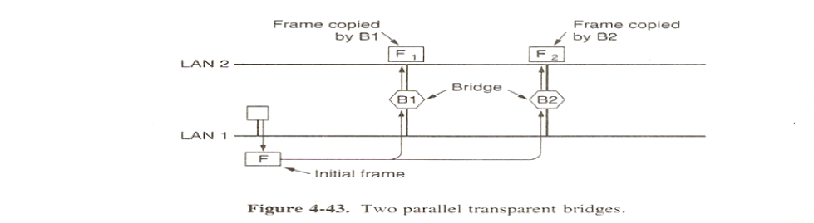
In fig.4.43, Here LAN1 transmitted a frame F. Then Bridge B1 reads F and make a copy as F1 and forwards to LAN2. And the same F was read by B2 from LAN1 and makes a copy a F2 and forwards to LAN2. Then the frame F1 from LAN2 was read by Bridge B2 and makes a copy of F3 and forwards it to LAN1 and F2 was made as F4 by Bridge B1 and kept in LAN1. Then F3 will become F5, F4 as F6 and so on and goes to an infinite loop of frames.
In fig. 4.44, To avoid this loop, we will avoid the CYCLE formation between the LANs and Bridges and we will form a spanning tree. So, B3- B4 line and B4- B5 line was broken to avoid the CYCLE which avoids the redundant copies of frames.

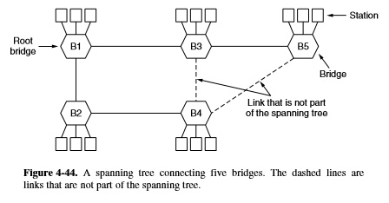
Remote Bridge -
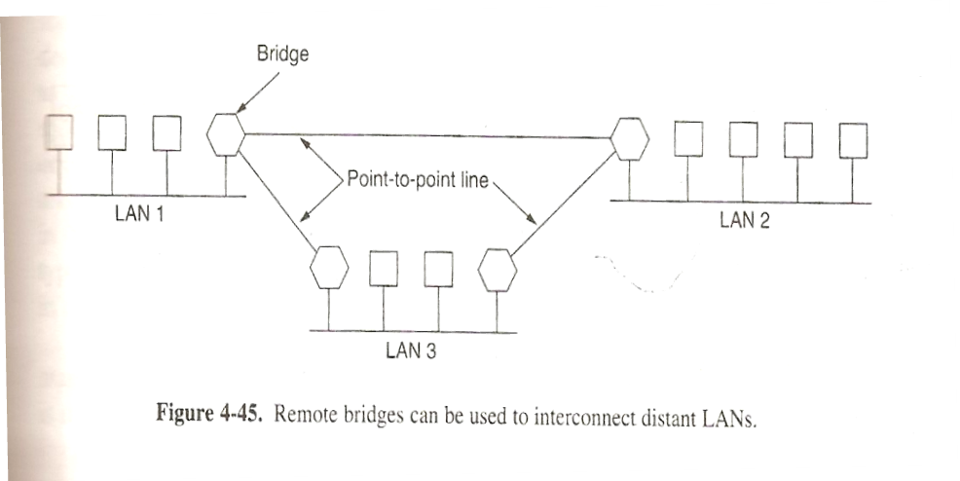
Here the LANs are very far i.e existing at a Remote place . But, the bridges are used to connect LAN1, LAN3 and LAN3 and LAN2.

Switch –
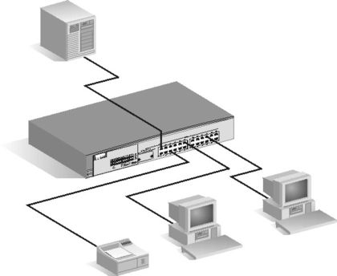
A network switch is a computer networking device that connects more than two network segments. It is referred as multiport Bridge.

Router-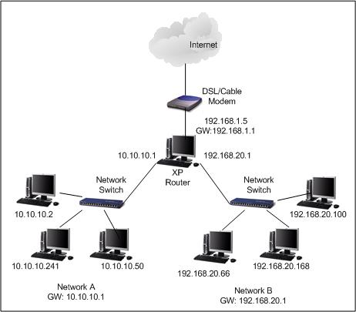
It is a device like a switch that connects more networks or computers and which has inbuilt software to generate the routes & find their shortest paths.

Gateway –
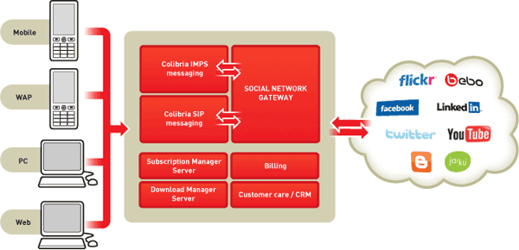
Imagine there are two networks A and B. A is using TCP/IP, B is using Apple protocols. Then to have data transfer between A and B , we need a Gateway in between A and B. i.e. protocol converter. Eg.- “TCP/IP – APPLE” Gateway.
These connect two computers/networks that use different connection oriented transport protocols. Application gateways understand the format and contents of the data and translate messages from one format to another.

Differences between Router and Gateway
1. Routers route packets of data from one network to another. Some routers even control the Internet’s infrastructure. Gateways are the portals that computers use to connect to the Internet. Sometimes one computer can be a gateway for others, which is made possible through Internet Connection Sharing (ICS).
2. In the typical Internet connection, the router coordinates data transfer from one computer to another within a network and to other networks The gateway is any device specifically designed to provide all the computers in a network with access to the World Wide Web.
3. Gateways regulate traffic between two dissimilar networks, while routers regulate traffic between similar networks. A gateway, on the other hand, joins dissimilar systems.
4. routers manage movement between comparative systems. Gateways direct activity between two disparate systems
5. The router is the physical equipment box Gateway is the area.

Differences between Repeater & Gateway.
repeater | gateway
- A repeater connects two segments of your network cable.  - Repeaters network model. work only at the physical layer of the OSI  3)it cannot transfer the message from one format to another format  4)repeater will not enable communication  5) A repeater regenerates the received signals and then retransmits the regenerated (or conditioned) signals on other segments. | - A gateway can translate information between different network data formats  - Most gateways operate at the application layer, but can operate at the network or session layer of the OSI model.  - It can transfer one format to another  4) Gateways make communication possible between different architectures and environments.  5) They repackage and convert data going from one environment to another so that each environment can understand the other's environment data.

Differences between Switch and Hub
1. Definition An electronic device that connects many network device together so that devices can exchange data A network switch is a computer networking device that is used to connect many devices together on a computer network. A switch is considered more advanced than a hub because a switch will on send msg to device that needs or request it
2. Layer Physical layer. Hubs are classified as Layer 1 devices per the OSI model. Data Link Layer. Network switches operate at Layer 2 of the OSI model.
3. Function To connect a network of personal computers together, they can be joined through a central hub. Allow to connect multiple device and port can be manage, Vlan can create security also can apply
4. Data Transmission form Electrical signal or bits Frame (L2 Switch) Frame & Packet (L3 switch)
5. Collisions Collisions occur commonly in setups using hubs. No collisions occur in a full-duplex switch.
6. Speed 10Mbps 10/100 Mbps, 1 Gbps
7. Transmission Type Hubs always perform frame flooding; may be unicast, multicast or broadcast First broadcast; then unicast & multicast as needed.
8. Device Type Passive Device (Without Software) Active Device (With Software) & Networking device
9. Transmission Mode Half duplex Half/Full duplex
10. Table A network hub cannot learn or store MAC address. Switches use content accessible memory CAM table which is typically accessed by ASIC (Application Specific integrated chips).
11. Spanning-Tree No Spanning-Tree Many Spanning-tree Possible
12 Ports 4/12 ports Switch is multi port Bridge. 24/48 ports
13. Example Routers by Sun Systems, Oracle and Cisco Switches by Cisco and D-link Juniper

